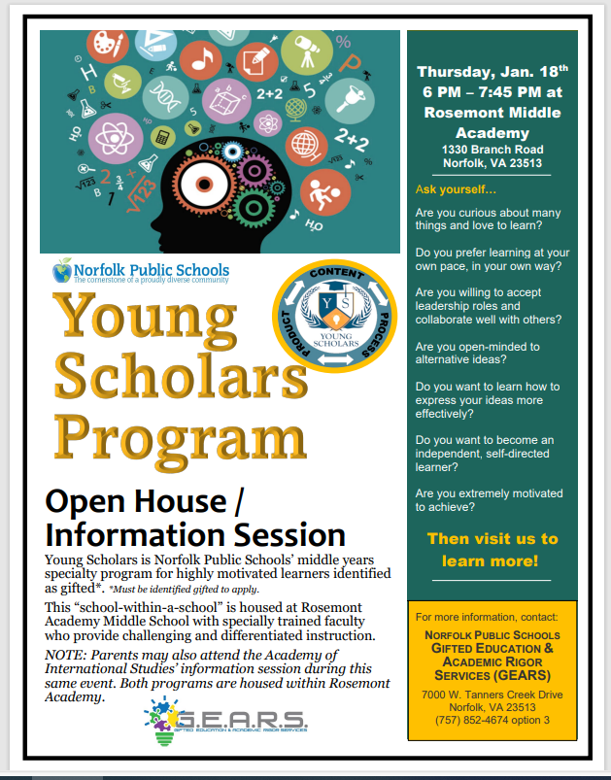
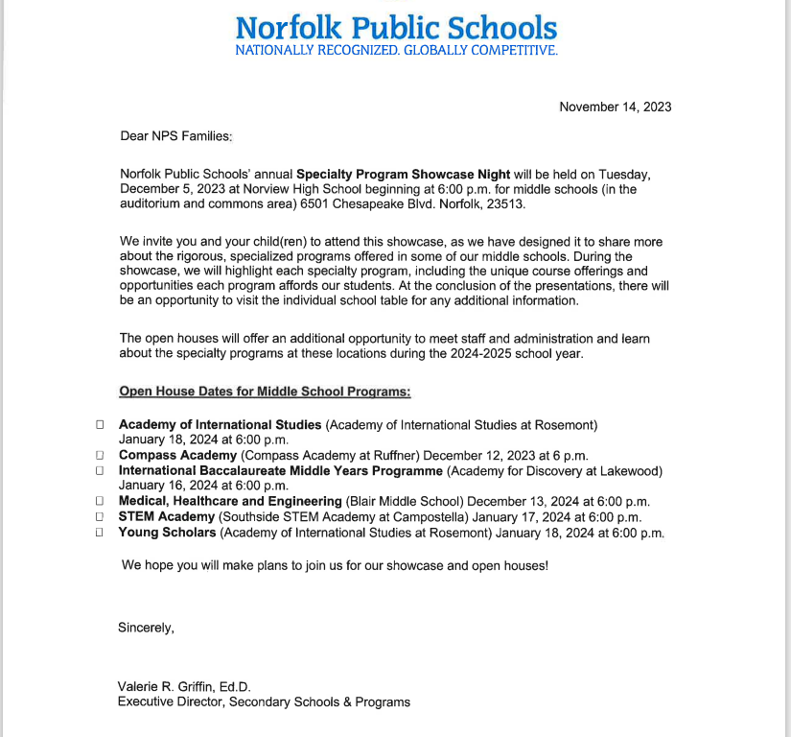

Link for Middle School Specialty Program Information:
Specialty Programs / Specialty Programs (npsk12.com)
Link for Middle School Specialty Program Application-Due January 31
Elementary and Middle School Specialty Program Application for the 2024-2025 School Year (google.com)

